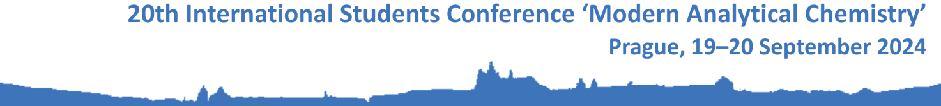

Registration Form

1. Personal details
Title (Mr. / Mrs. / Ms. / other)
First (given) name(s)
Surname
Organization (in English)
Organization’s address
Postal code, city
Country
E-mail address

2. Title of the contribution

3. In the conference proceedings, I will publish:
abstract / full contribution

4. Interest in the publication of the contribution in the conference issue of the journal Monatshefte für Chemie
The organizers of the 20th International Students Conference ‘Modern Analytical Chemistry’ are in negotiations with the editors of the journal Monatshefte für Chemie-Chemistry Monthly (IF₂₀₂₂ = 1.8, Q3) on the possibility of publishing selected contributions presented at the conference as regular articles in this journal. Are you interested in this possibility?
YES/NO

5. Accommodation
I require accommodation from 18th to 22nd September 2024 in the hotel ‘Krystal’:
The organizers regret, but the capacity of free accommodation is already exhausted. Participants of the conference have to arrange their own accommodation.

6. Lunches
I require the conference lunches by the organizers:
September 19 | YES/NO
September 20 | YES/NO

Please indicate if you have any limitations (e.g., vegetarian food):

7. Any other notes/requirements

