Space App Camp 2015
It's that time again: Professional app developers from all across Europe can now apply to participate in this year's Space App Camp by 22 July 2015.
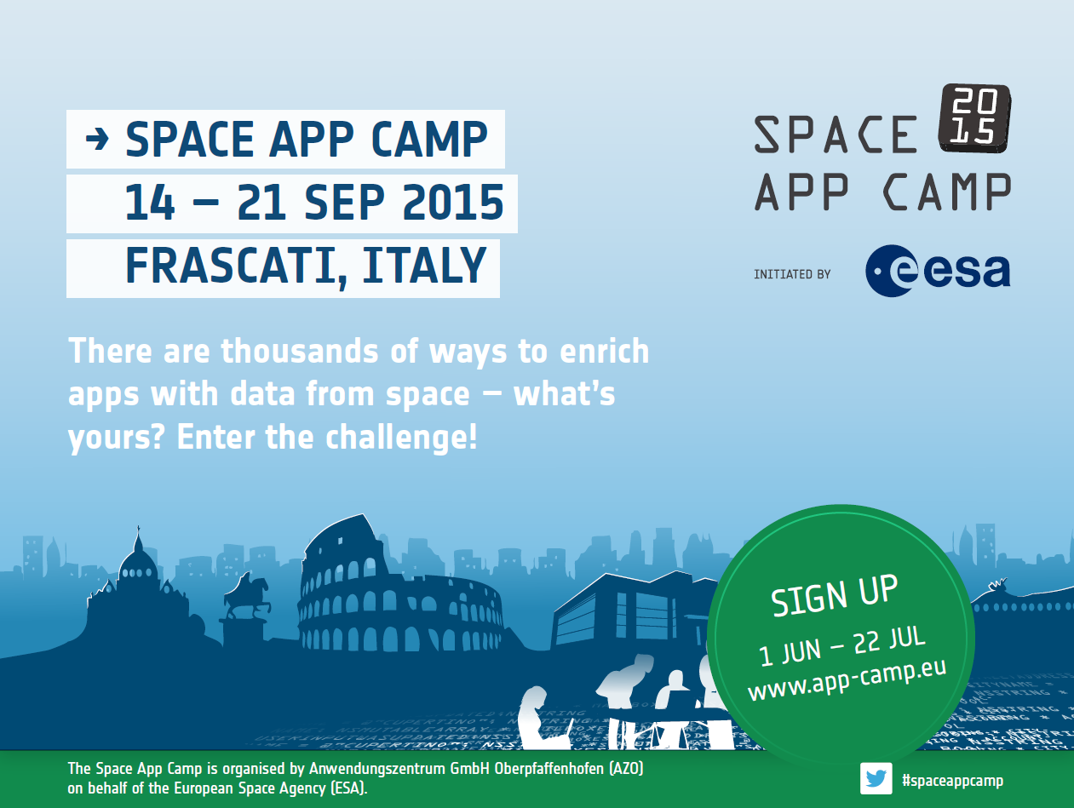
The European Space Agency (ESA) is about to invite 20 committed developers to its fourth Space App Camp, a free event scheduled for 14-21 September 2015 at the Agency's ESRIN facility in Frascati (near Rome), Italy.
Tremendous amounts of data from space – the kind produced by the European Earth observation programme Copernicus and its Sentinel satellites – presents countless opportunities in connection with mobile applications.
This is where the Space App Camp comes in, bringing programmers together to develop creative and innovative apps that make Earth observation data, in particular those received from Copernicus, accessible to a wide range of citizens.
That said, this event is more than just another competition for app developers. Its main goals are to help participants learn about the many ways satellite data can be used in mobile apps, make contacts all over Europe, and gain exciting insights into how ESA operates.
Camp attendees are encouraged to develop creative solutions to global challenges. Working in teams, they will be tasked with developing innovative apps and feasible business models for one of five subject areas: agriculture; emergency and rescue management; environmental protection; marine environments and maritime transportation; or lifestyle and tourism.
Those interested can register online as individuals or teams (of up to four people) at www.app-camp.eu from 1 June to 22 July, choosing their preferred category in the process. The selection criteria will include the applicants' previous programming work. Travel and accommodation will be covered by the event's organisers.
News from past App Camp participants:
Ceptu set to bring FieldSense app to market
The Ceptu adventure began in May 2014 when four computer science students from Aarhus University (Denmark) won the Space App Camp in Noordwijk (the Netherlands) with their app concept FieldSense. This innovation uses satellite data from the Copernicus missions to aid farmers in managing their harvests. Bolstered by this success, the group behind FieldSense then submitted their app to the innovation competition Copernicus Masters, where it won the CloudEO Farming Challenge. They founded a start-up called Ceptu shortly thereafter in order to ready the app for the market.
"Participating in the App Camp and Copernicus Masters, making lots of contacts, gathering all kinds of feedback – all of this has been a tremendous help in taking our idea further and developing it into a commercial product through our start-up," reports John Smedegaard, one of the co-founders of Ceptu.
The company just recently became one of the first to be accepted into the new incubation programme at Aarhus University and the SmartAgriFood business accelerator. A FieldSense prototype is to be completed by the end of this summer, with the market-ready app scheduled for launch at the start of the harvest season in 2016.

Anwendungszentrum GmbH Oberpfaffenhofen – an experienced organiser
Anwendungszentrum GmbH Oberpfaffenhofen (AZO) has been organising the Space App Camp on behalf of the European Space Agency since 2012. By leveraging its extensive experience as a specialist in building and maintaining global innovation networks and carrying out related competitions, AZO supports product innovations and the creation of new companies, particularly in the field of commercial aerospace applications. www.anwendungszentrum.de

