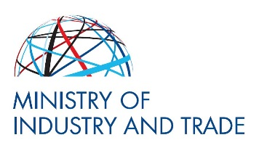
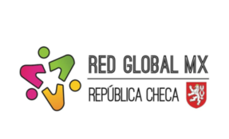
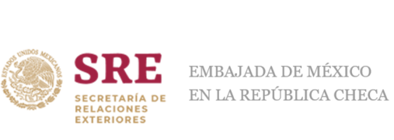

Ministry of Industry and Trade, Embassy of Mexico to the Czech Republic and the Red Global MX
cordially invite you to the
3rd Science and Innovation Day Mexico – Czech Republic
that will be held on 28th of June 2022 at 10 am at the Ministry of Industry and Trade, Politických Vězňů 20, Prague 1
Goals:
- Present the policies and programs of the State of Jalisco and the Czech Republic that have been developed along the years to build their innovation ecosystems, the connector with businesses, universities, startups, and investors to create opportunities and foster innovation.
- Learn how these innovation ecosystems work to provide impact solutions to improve quality of life to both societies.
- Exchange of practical experiences in supporting startups, talent management and facilitating the internationalization processes.
- Examine how the Mexican and the Czech innovation ecosystems can collaborate to establish bilateral cooperation.
- Strengthen scientific and innovation cooperation between Mexico and the Czech Republic.
- Continuing consolidating the annual Day of Science and Innovation Day Mexico – Czech Republic that started in 2019.
Programme:
9:30 – 10:00 - Registration
10:00 – 10:30 - Opening Session
10:30 – 11:00 - Innovation ecosystem of the State of Jalisco
11:00 – 11:10 - Coffee Break
11:10 – 11:40 - Innovation ecosystem of the Czech Republic
11:40 – 11:50 - Overview of entrepreneurship and innovation collaborations Czech Republic –
Jalisco
11:50 – 12:20 - Round table
12:20 – 12:30 - Closing Remarks

The event will be held in English and is free of charge.
For registration please fill in the registration form till 26th of June.
If you wish, feel free to contact jenickovam@mpo.cz.

