Collecting of courses for virtual mobility
(for summer semester 2021/2022)

Courses to be collected
There are two types of collected courses.
- The 4EU+ shared courses – taught already at Charles University, that fulfil all conditions stated below, and their teachers are willing to accept students from 4EU+ universities and from three strategic partners (University of Zürich, Macquarie University, University of St Andrews)
- The 4EU+ courses – accredited at CU, created under alliance cooperation, for example within the educational project

The process of collection
The 4EU+ faculty coordinators are responsible for spread the data for collection. The collection is done directly in SIS by ticking “Virtual mobility” in the course description (see picture 1) and completing all information stated below. The deadline for collection is December, 3.
Later, all courses will have to be approved by heads of departments and also by the flagship coordinators (if the course belongs to one of the flagships).
After the approval, all courses will be published on the 4EU+ website and in January, students of all 4EU+ and strategic partners’ universities meeting the conditions can apply for them.

Conditions of courses
- All course has to be accessible virtually (lectures, seminars, materials, examination, presentations…), or it has to be blended (virtual course accompanied by short-term physical mobility).
- The language of instruction must be English or some of the alliance languages except Czech.
- The course has to belong to one of the four flagships and/or develop one or two transversal skills (see below).
- The course is open without costs to the 4EU+ students.

Flagships
- Health and demographic change in an urban environment
- Europe in a changing world: understanding and engaging societies, economies, cultures, and languages
- Transforming science and society advancing information, computation, and communication
- Bio-diversity and sustainable development

Transversal skills
To meet the transversal skill, it should be stated as one of the main learning outcomes of the course.
- Multilingualism (language and linguistic courses)
- Data literacy
- Critical thinking
- Entrepreneurship
- Social engagement

Information about the course
- Title
- Code
- Guarantor
- All lecturers
- Faculty, department
- Credits
- Language of instruction
- Flagship and/or transversal skills
- Capacity
- Examination
- Minimal requirements, prerequisites, conditions for selection and enrolment of students (nota as requisites for virtual mobility, see picture 2)
- Virtual mobility
- How the course will be taught (weekly, every second week…) and the starting date
This information as well as the complete syllabus have to be in English.

Contacts
General information, mobility issues: tereza.vosejpkova@ruk.cuni.cz
E-learning support: karolina.savincova@ruk.cuni.cz
SIS support: martin.manasek@ruk.cuni.cz
European centre: kristyna.kolinova@ruk.cuni.cz

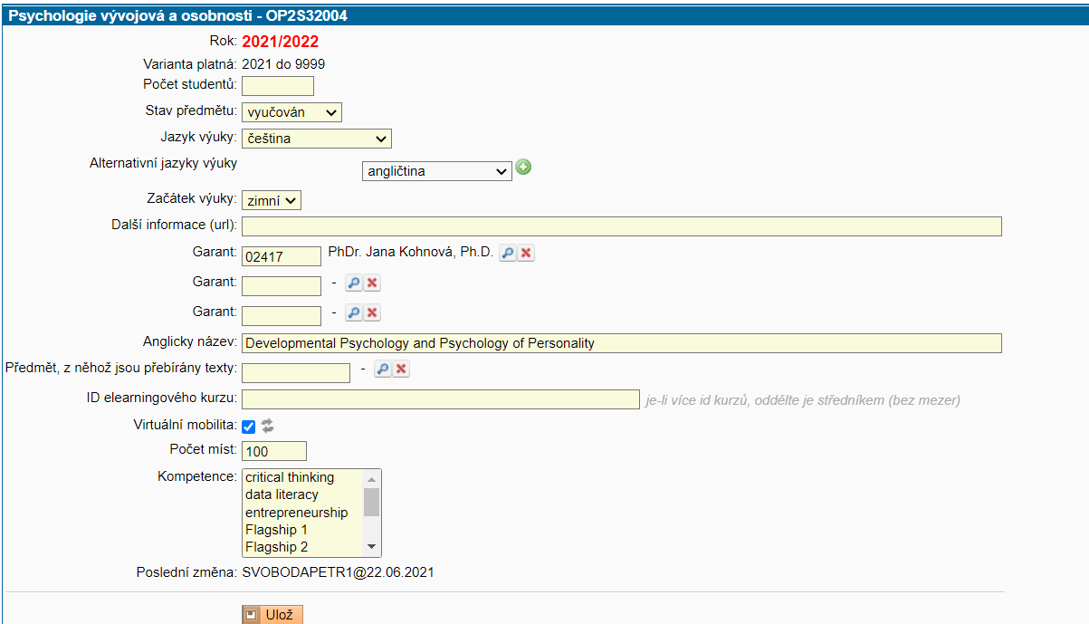
Picture 1

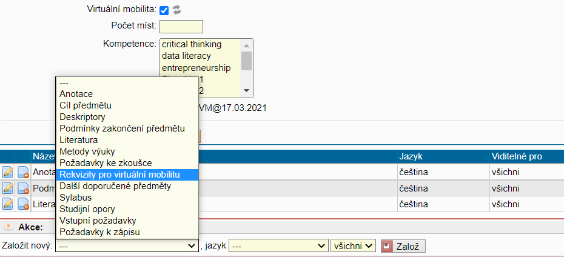

Picture 2

