CHARLES UNIVERSITY, FACULTY OF SCIENCE
Prague 2, Albetov 6

INSTRUCTION ON RISKS AND SAFE BEHAVIOUR IN THE AREA
Before entering UK-Professional Faculty premises, each person must be made aware of the risks and instructed in safe behaviour in the Faculty's buildings and workplaces

BASIC SAFETY RULES
- In the premises and workplaces of the UK-Professional Faculty, each person shall comply with all applicable legal rules and regulations on occupational safety, health and fire protection
- Access to the workplace is only possible when accompanied by a responsible person.
- When entering hazardous workplaces (laboratories, workshops, etc.), personal protective equipment must be used. Work equipment as ordered by the head of the workplace
- When moving around in hazardous workplaces (laboratories, workshops, etc.), the instructions of the attendant must be observed by the person in charge. Do not touch anything in these workplaces without instructions.
- In the event of discovering possible dangers to health and life, these cases must be reported immediately to the building porter or the person in charge
- Report the occurrence of an accident immediately to the person in charge.
- Observe the prohibitions and warnings of the safety warning signs posted on the workplaces
- In the event of an emergency when an evacuation is declared, evacuation routes are marked with green signs with white pictograms indicating the direction of escape.
- Information on the direction of escape when evacuating persons shall be provided according to the graphic evacuation plans posted in prominent locations in the corridors of faculty buildings.
- When an emergency is declared by a siren signal (beating on the rail, voice "THUNDER"), each person must leave the building as soon as possible

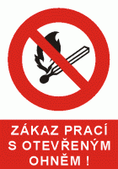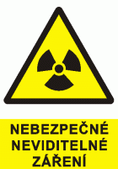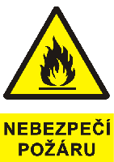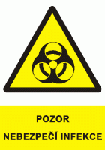

IT IS PROHIBITED:
- Smoking in all faculty buildings.
- Entering and remaining in areas defined by barricades, warning signs and marked
- Handling equipment in hazardous work areas (labs,workshops,etc.).
- Handle chemical substances

EMERGENCY LINES
Firefighters First Aid Police SOS
150 155 158 112

The person entering the faculty building confirms by signing here that he/she has read the above text, understands its contents and undertakes to follow the instructions given here
Name and signature Name and signature
………………………………………. ……………………………………….
………………………………………. ……………………………………….
………………………………………. ……………………………………….
………………………………………. ……………………………………….
………………………………………. ……………………………………….
………………………………………. ……………………………………….
………………………………………. ……………………………………….
………………………………………. ……………………………………….
………………………………………. ……………………………………….
………………………………………. ……………………………………….
………………………………………. ……………………………………….
………………………………………. ……………………………………….
………………………………………. ……………………………………….
………………………………………. ……………………………………….
………………………………………. ……………………………………….
………………………………………. ……………………………………….
………………………………………. ……………………………………….
………………………………………. ……………………………………….
………………………………………. ……………………………………….
………………………………………. ……………………………………….
………………………………………. ……………………………………….
………………………………………. ……………………………………….
………………………………………. ……………………………………….
………………………………………. ……………………………………….

