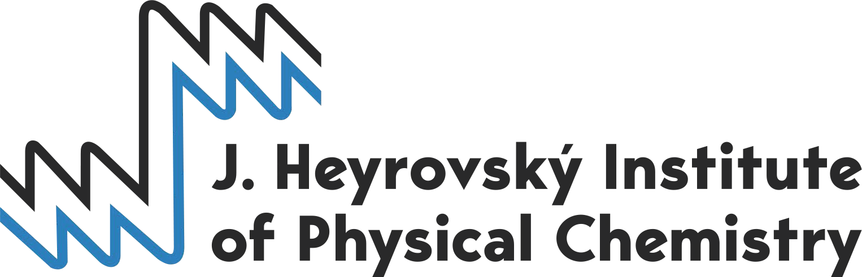

Registration for the
4th Cross-Border Seminar on Electroanalytical Chemistry (CBSEC),
Prague, 11. – 13. April 2022

Name:

Surname:

Academic title(s):

E-mail address: Phone:

Birth date:

Passport or personal ID number:

Nationality:

Affiliation (university/institute, department, address):

Supervisor:

Preliminary title of your contribution:

Please, fill this form in and send it to tomas.krizek@natur.cuni.cz, and copy to barek@natur.cuni.cz and Frank-Michael.Matysik@chemie.uni-regensburg.de by 15. March 2022.
The registration form can be filled in electronically or printed and scanned.
Please, note that the seminar is for Ph.D. students only.

