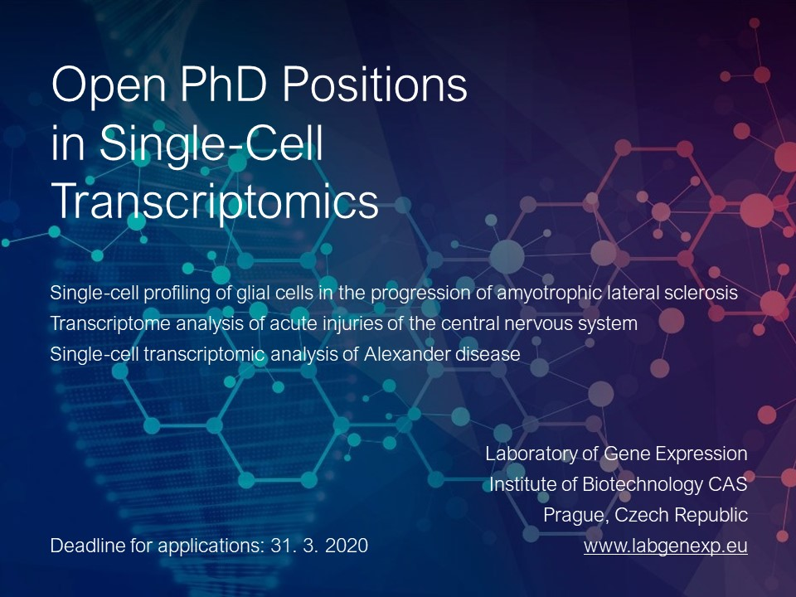
Open PhD Positions in Single-Cell Transcriptomics

The Laboratory of Gene Expression is a well-funded research laboratory with an excellent publication track record, comprised of researchers with unique scientific expertise. We focus on gene expression studies using a combination of up-to date techniques such as single cell expression profiling and next-generation sequencing. We have research projects in the ﬁeld of neurobiology and we are involved in the development of methods for nucleic acids analyses.
We offer three PhD positions:
- Single-cell profiling of glial cells in the progression of amyotrophic lateral sclerosis
- Transcriptome analysis of acute injuries of the central nervous system
- Single-cell transcriptomic analysis of Alexander disease
The successful candidate will be responsible for complete gene expression analysis, including sample preparation, quality control, RT-qPCR and RNA-Seq profiling with single-cell resolution and data analysis. The candidate should have good background in genetics, molecular and cell biology. Basic knowledge or interest in scientific programming (e.g. R, Python, Unix) is advantageous. Previous experience in neurobiology or gene expression analysis using RT-qPCR or RNA-Seq are appreciated, although not necessary. As the project will be performed in collaboration, good communication skills, willingness to learn, and proactive attitude are absolutely mandatory. The positions are suitable for wet-lab as well as dry-lab scientists; based on candidate´s preferences (the interdisciplinary skills are welcomed).
We offer a friendly and supportive environment, secured financing, possibility to work with cutting-edge techniques and good opportunities for publications. The laboratory is located in the new state-of-the-art BIOCEV research center.
Deadline for applications: 31. 3. 2020
Interested applicants should contact Dr. Lukas Valihrach (lukas.valihrach@ibt.cas.cz) or Prof. Mikael Kubista (mikael.kubista@ibt.cas.cz) and include their CV, cover letter describing their background and research interests and two contacts for reference.

Join us and work with the technology that will shape life sciences in the 2020s!
https://www.labgenexp.eu/news/open-phd-positions

