PhD positions in Molecular Life Sciences at MFPL

The Max F. Perutz Laboratories provide interdisciplinary PhD training, high‐quality research, a full‐ time contract and a competitive salary for outstanding university graduates. The MFPL are situated at the Vienna Biocenter (VBC), a major science hotspot in Europe. Students and scientists benefit from the excellent scientific networks between the research institutes and companies at the VBC.

We at the Max F. Perutz Laboratories are committed to providing a creative space for discoveries. Our research covers a broad range of the molecular biosciences, exploring life at the cellular, molecular and atomic levels. All students and scientists benefit from excellent scientific facilities.

Our institute is characterized by a spirit of sharing ideas and resources. Currently, 130 PhD students from more than 30 nations work at the MFPL, creating an open, interactive atmosphere. English is the official working language.

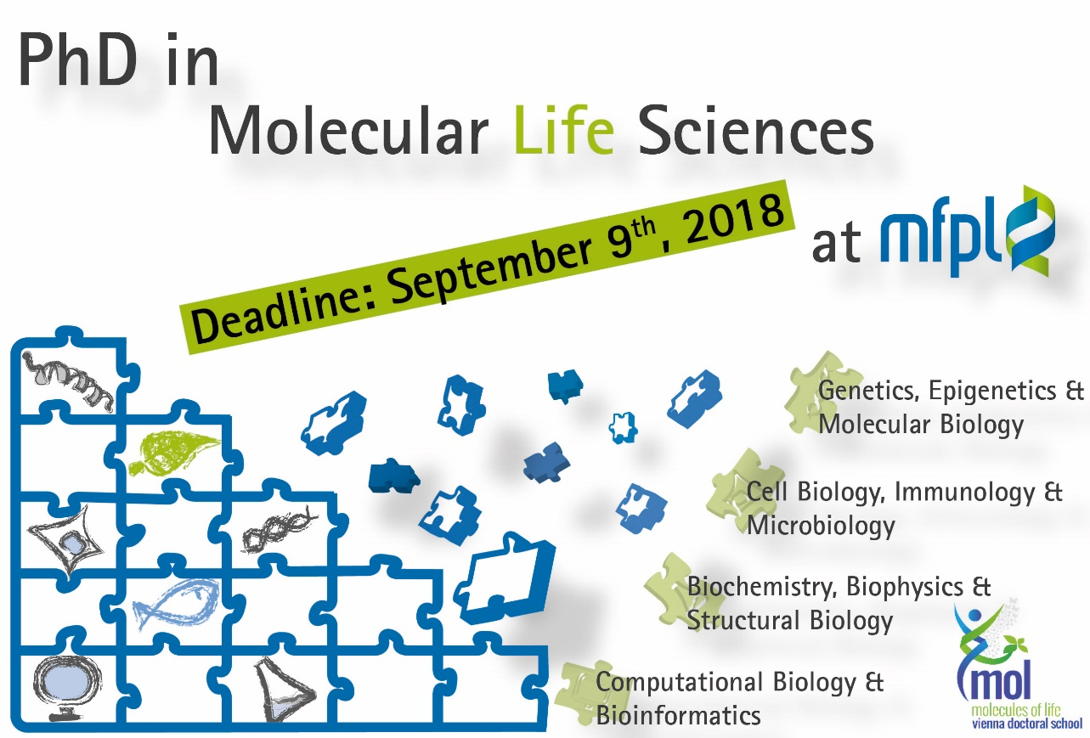

PhD Education

The Max F. Perutz Laboratories are home to the interdisciplinary training provided by the Vienna Doctoral School “Molecules of Life”, established to foster education, cooperation and interaction among students and group leaders from different backgrounds and disciplines in an open and creative environment. By promoting the exchange of ideas and inspiring insights from unexpected perspectives as well as the introduction of novel technologies, “Molecules of Life” provides ambitious and motivated students with the training opportunities they need to become the next generation leaders in the Molecular Life Sciences.

The Vienna Doctoral School “Molecules of Life” advances PhD education by providing a forum for excellent PhD students and their supervisors to freely exchange and critically challenge ideas.

The curriculum has a minimum duration of three years, and extension is possible. Our students obtain a PhD Degree conferred by the University of Vienna or by the Medical University of Vienna, depending on the affiliation of the Supervisor, and /or based on the topic of the thesis.

Selected students will receive a competitive salary according to the guidelines set by the Austrian Science and Research Fund, including full social benefits.

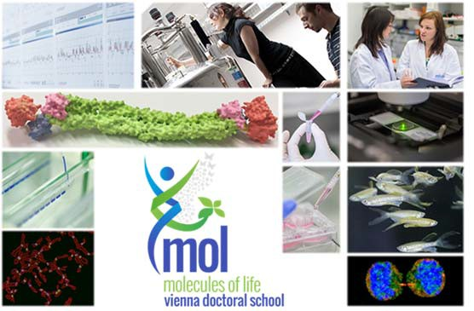

Your application

Our web page http://www.mfpl.ac.at/training/phd‐opportunities/how‐to‐apply.html gives detailed information for submission of application. Only complete applications submitted by Sept. 9, 2018 will be taken into consideration.

Applicants must hold or anticipate receiving a Master’s degree or equivalent from a university in a relevant field.

Contact details
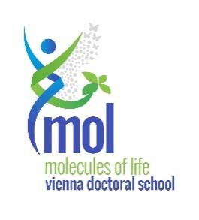
Gerlinde Aschauer
VDS „Molecules of Life“
Max F. Perutz Laboratories
Vienna Biocenter
Dr. Bohr‐Gasse 9
A‐1030 Vienna Austria

Email: positions@mfpfl.ac.at
Website: http://www.vds‐molecules‐of‐life.org

